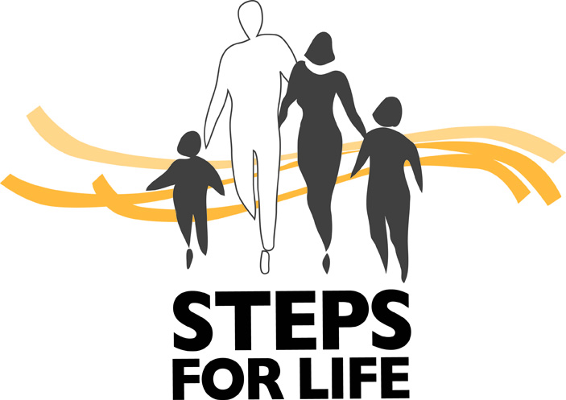 Steps for Life – Sponsorship Work Sheet

Step 1 – Set Your Sponsorship Goal
(What’s the grand total you’d like to raise?)

$
Example: Sponsorship Tracking Sheet
(Electronic template is available – just ask!)

Step 2 – Break It Down
(Determine what levels of sponsorship you’d like to ask for to achieve the overall goal?)

# x $2,000 = $
# x $1,500 = $
# x $1,000 = $
# x $500 = $
# x $250 = $
# x other = $
Total = $
(this should equal overall goal)

Note: In-Kind values are considered for levels under a $1000 – refer to sponsorship package for more information.
Step 3 – Research and Plan
(Know who you are going to ask, and who’s doing the asking?)

This phase is critical. Knowing whom you are going to ask ahead of time is beneficial. Your list should include previous supporters, contacts that may have given in the past that maybe didn’t last year, and of course new contacts (this is where the research comes in and brainstorming with the committee). Developing a tracking sheet will help with this process – see the example used in Hamilton.
…and Lastly – Make the Ask!

Don’t forget to use the tools provided for you to assist with your ask, including template letters, email, sponsorship packages and forms, plus signage examples, and not to mention your pictures, etc.

All of these resources, in addition to your careful planning and follow-up, will undoubtedly lend to your success in reaching your community fundraising goal!

And as always, your Regional Development Coordinator is here to answer any sponsorship questions you may have.
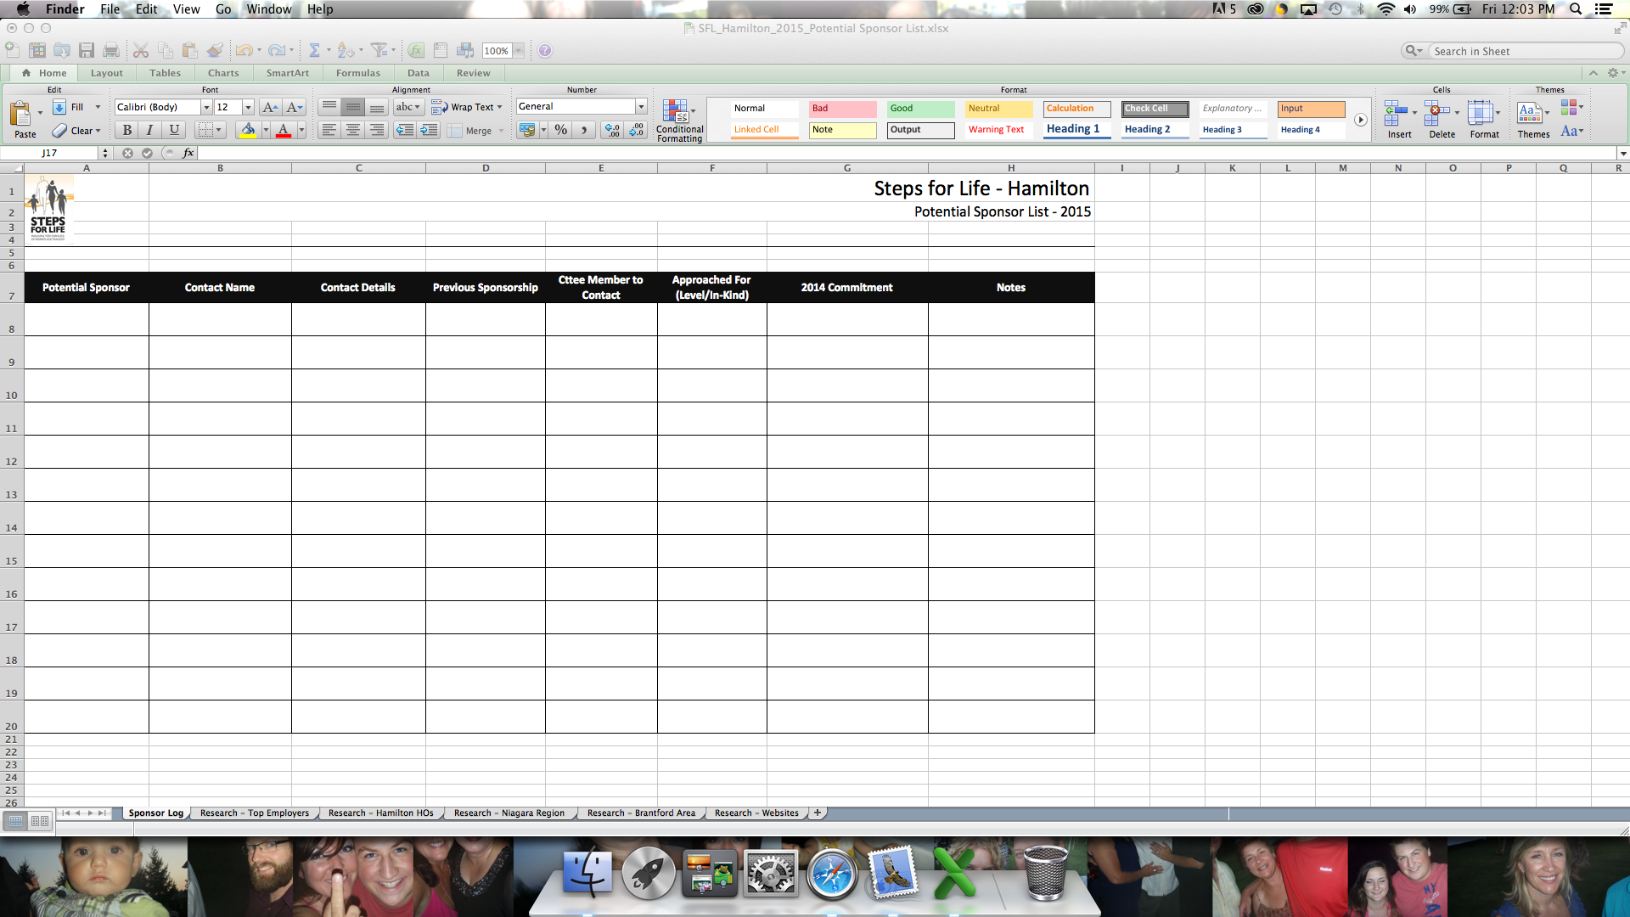

Note: The tabs on this work sheet included a log of potential sponsors and on previous supporters, plus research tabs collecting best employer, head office and surrounding area data, which combined made up the “growing ask” list.

